**AI ASSISTED CODING**

**ASSIGNMENT-6.3**

Name: S. Vrindha Reddy

Hall Number.: 2403A51255

Batch No.:11

**Task 1**

* Use AI to complete a student class with attributes and a method.
* Check output
* Analyze the code generated by AI tool

**Instructions:**

* Initialize class with attributes like name, roll no, marks
* Method to display student details
* Method to calculate grade based on marks (A:>=90, B: >=75, C: >=60, else Fail)

Start Writing code and auto complete using any AI tool

**Expected Output-1:**

* Class with constructor and display_details () method

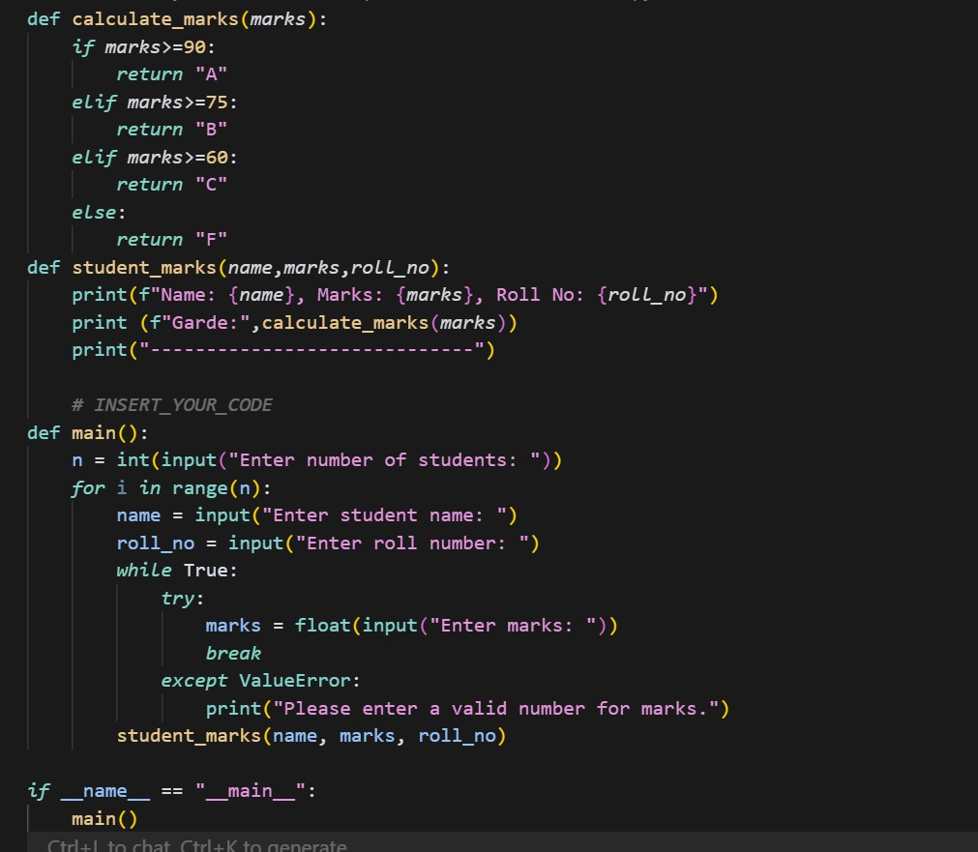

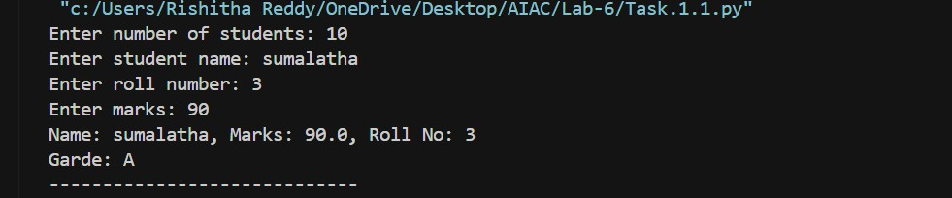OUTPUT:

**Task -2 (Loops)**

* Prompt AI to complete a function that prints the first 10 multiples of a number using a loop.
* Analyze the generated code
* Ask AI to generate code using other controlled looping.

**Expected Output-2:**

* Correct loop-based implementation

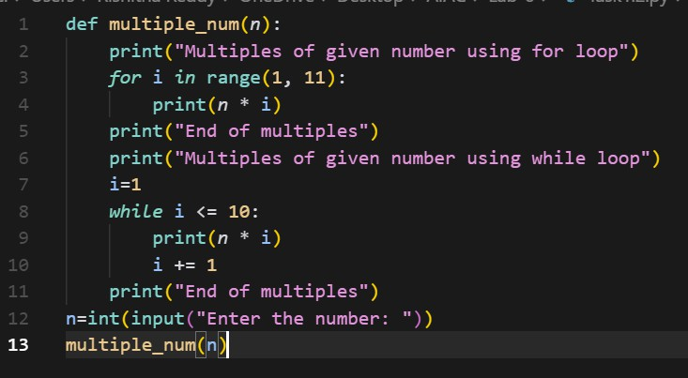

**OUTPUT:**

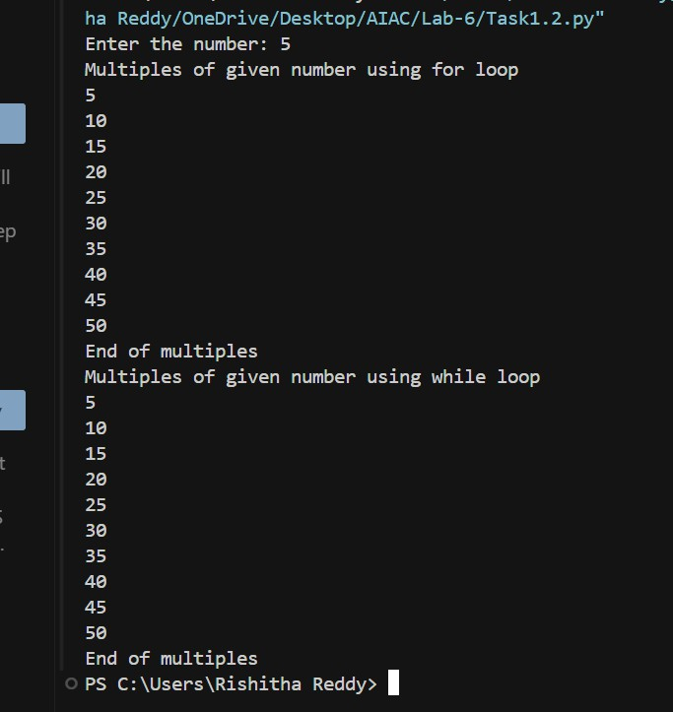

**Task Description#3 (Conditional Statements)**

* Ask AI to write nested if-elif-else conditionals to classify age groups.
* Analyze the generated code
* Ask AI to generate code using other conditional statements.

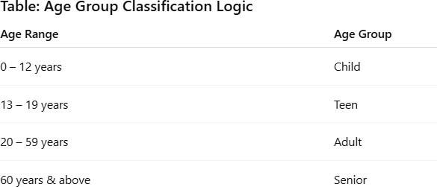

* ​

**Expected Output-3**

* Age classification function with appropriate conditions and with explanation

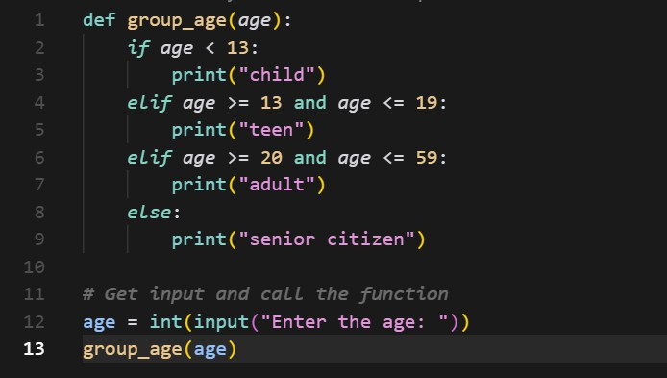

**OUTPUT:**

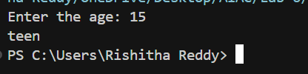

**Task Description#4 (For and While loops)**

* **Generate a sum_to_n() function to calculate sum of first n numbers**
* **Analyze the generated code**
* **Get suggestions from AI with other controlled looping**

**Expected Output-4:**

* **Python code with explanation**

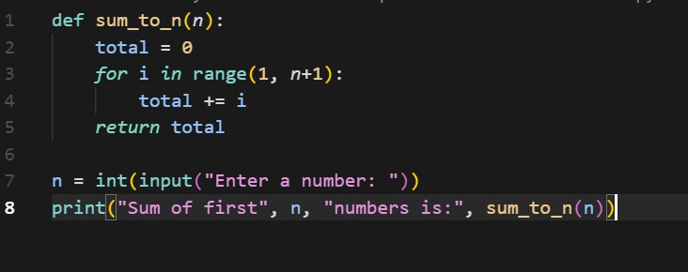

OUTPUT:

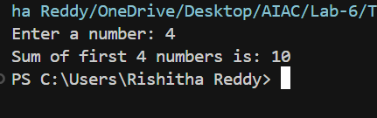

**Task Description#5 (Class)**

* Use AI to build a Bank Account class with deposit, withdraw, and balance methods.
* Analyze the generated code
* Add comments and explain code

**Instructions**

* **Initialize Bank Account class with attributes like name, balance**
* **Method to deposit amount**
* **Method to withdraw amount**
* **Method to check balance**

**Expected Output-5:**

* Python code with explanation
* 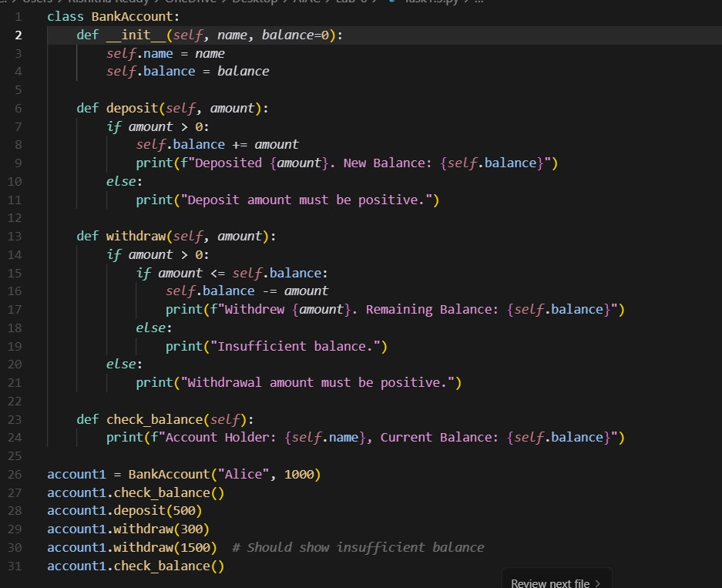

**OUTPUT:**

